Cookie Entrepreneur Pins/Badges


While you are logged in to Digital Cookie, click the link for “Badges” to be taken to the Cookie Entrepreneur Family Pins and Cookie Business badges that your Girl Scout can view and complete.

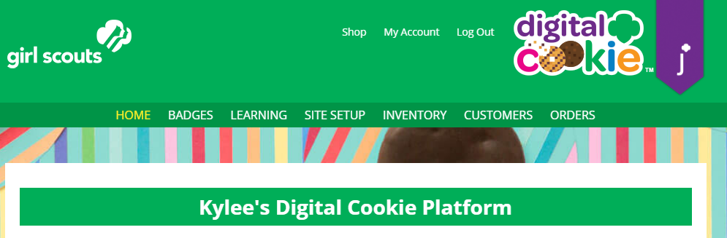


You’ll be taken to a page that displays the Cookie Entrepreneur Pins and the Cookie Business badges appropriate to your Girl Scout’s level.
Girls can click on the instructions for each step:

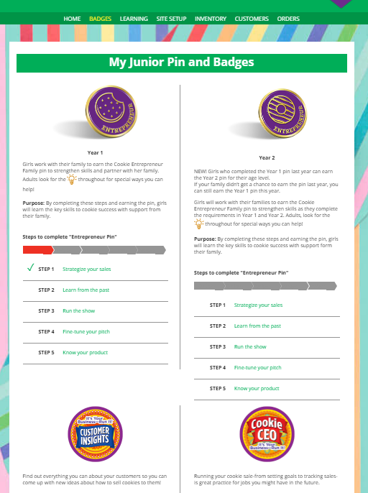
Click on a step.


The instructions for that step will pop up.
If there are activities within Digital Cookie that will help her complete the step, links will be included.
When she is finished with each step, she can check the box to show she completed it.

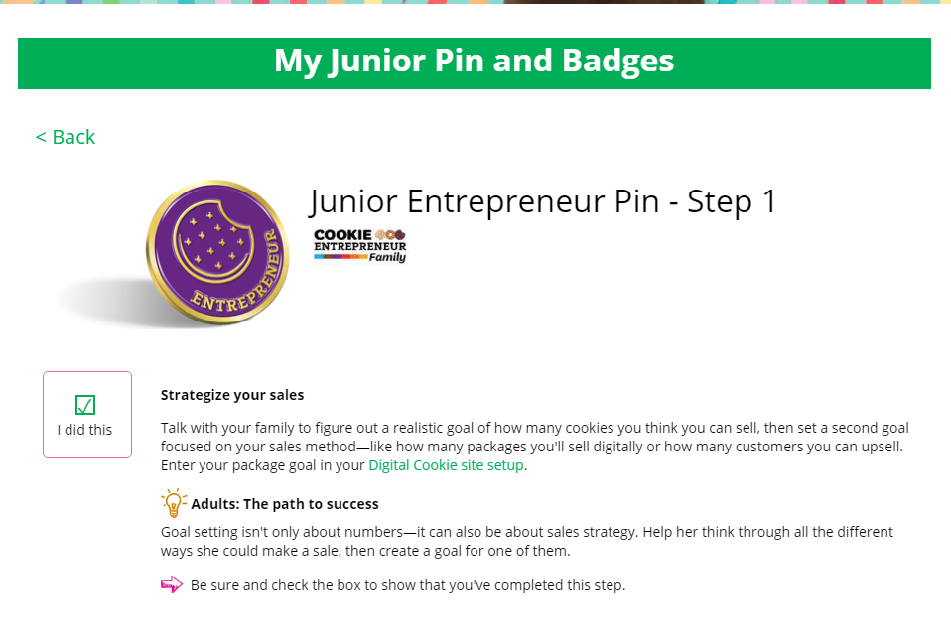
Link to activities she can complete in the site.

Check the box when the activity is finished.

NOTE that when a girl checks the box for the last step in earning that badge, she will get a pop-up asking her to confirm it. Once she marks the steps as complete and the badge earned, she can’t go back.

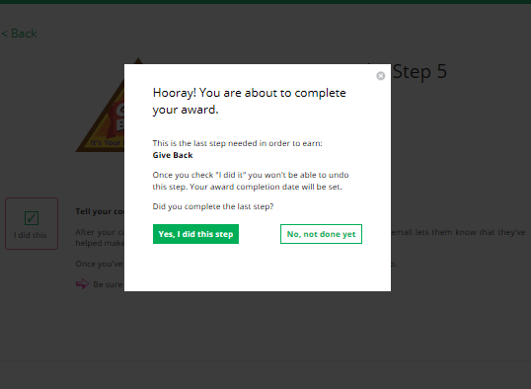


When she marks the box as completed, it will show as completed on her badge page.
Girls can mark the steps as completed even if they finished the badge earlier. If she wants to do the steps again, she can— they are all great tools for her cookie sale.
When she has completed all the steps, a star will appear at the end of her progress bar and she will get a message of congratulations!

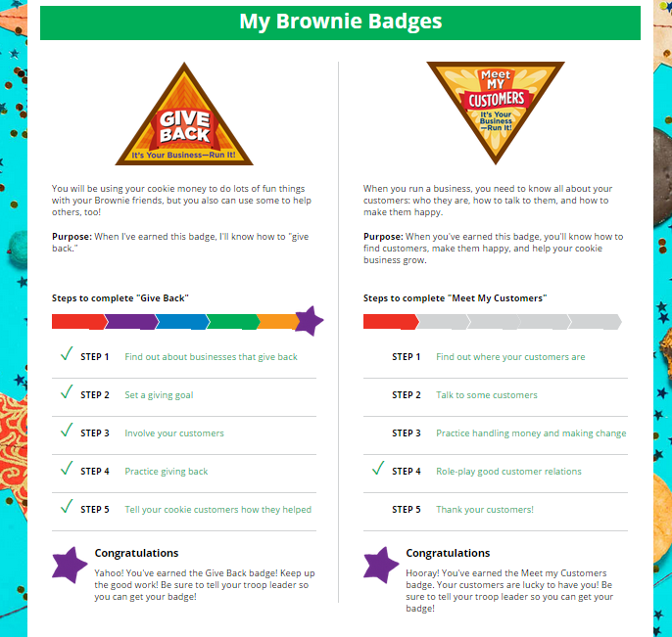
Girls should let their leaders know when they complete the badge or pin,
Activity Completed-


Once the girl has completed her badge it will display in color on her home page.

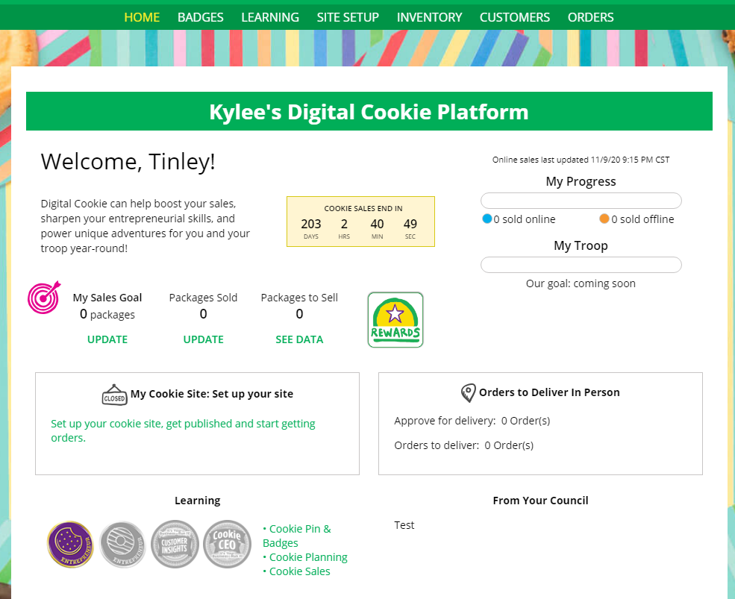
Completed badges/pins are in color.

